Install Prometheus and Grafana on a Linux EC2 machine, connect Prometheus to Grafana, and create a dashboard to view metrics.

Command used:

EC2:

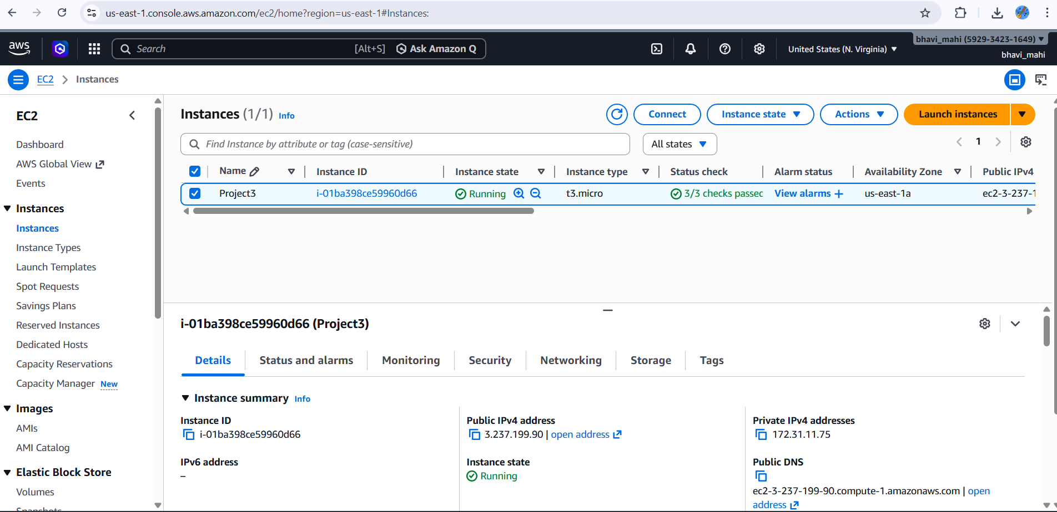

Prometheus:

Install:

wget https://github.com/prometheus/prometheus/releases/latest/download/prometheus-2.48.0.linux-amd64.tar.gz

tar xvf prometheus-*.tar.gz
cd prometheus-*

./prometheus --config.file=prometheus.yml

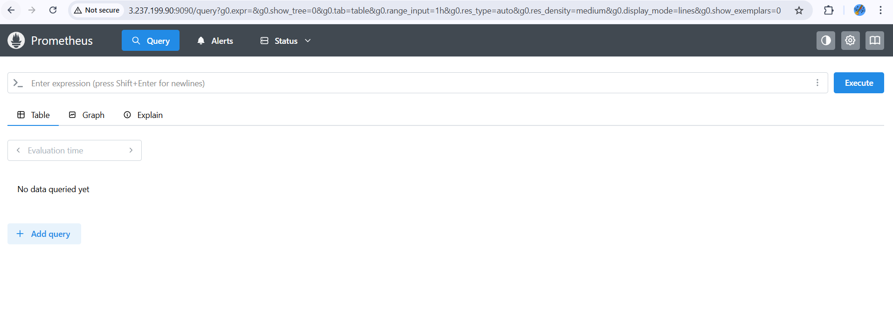
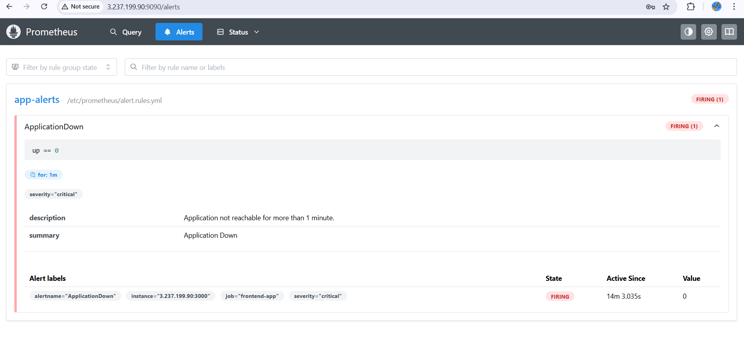
Grafana:
sudo apt-get install -y software-properties-common
sudo apt-get install -y Grafana
sudo systemctl start grafana-server
sudo systemctl enable grafana-server

